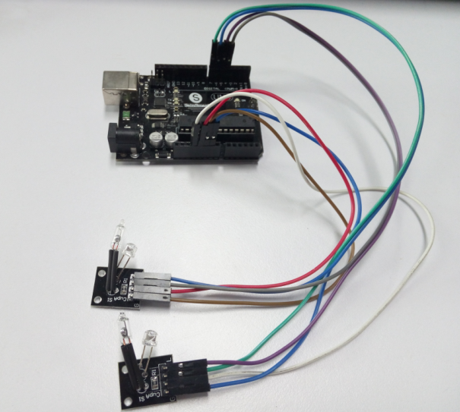

int LedPinA = 5;

int LedPinB = 6;

int ButtonPinA = 7;

int ButtonPinB = 4;

int buttonStateA = 0;

int buttonStateB = 0;

int brightness = 0;

void setup()

{

pinMode(LedPinA, OUTPUT);

pinMode(LedPinB, OUTPUT);

pinMode(ButtonPinA, INPUT);

pinMode(ButtonPinB, INPUT);

}

void loop()

{

buttonStateA = digitalRead(ButtonPinA);

if (buttonStateA == HIGH && brightness != 255)

{

brightness ++;

}

buttonStateB = digitalRead(ButtonPinB);

if (buttonStateB == HIGH && brightness != 0)

{

brightness --;

}

analogWrite(LedPinA, brightness); // A gradually become dark

analogWrite(LedPinB, 255 - brightness); // B gradually become bright

delay(25);

}